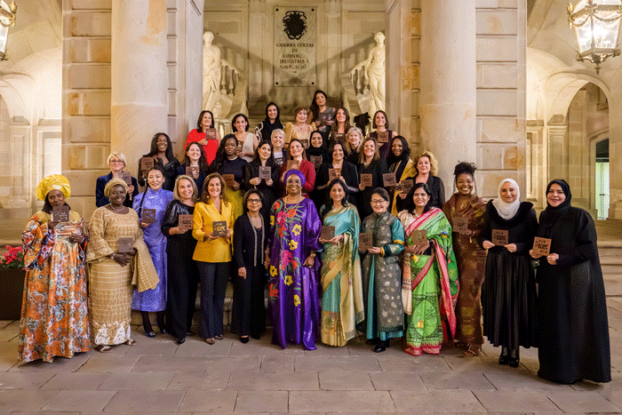

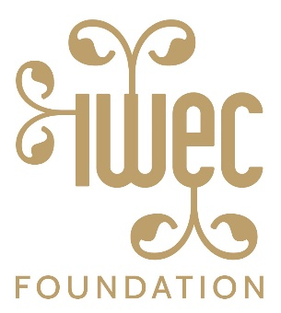

**2026 IWEC Awards Application**

The International Women Entrepreneurial Challenge was established in Barcelona in 2007, with the goal of connecting small & mid-size women business owners globally - those who are already in the global marketplace & want to expand or are ripe to get into the market and learn from other women leaders. Also, an important aspect of IWEC awardees is their commitment to Corporate Social Responsibility programs in mentoring, board participation, community outreach, sustainability, etc.

The Barcelona Chamber of Commerce, Federation of Chambers of Commerce in India/FLO (FICCI-FLO) and Manhattan Chamber of Commerce originated this initiative along with The US State Department and all were quickly joined by The Cape Chamber of Commerce and soon after, The Confederation of Asia Pacific Chambers of Commerce & Industry Women Entrepreneurs Council (CWEC). Each year a new country/chamber is added to the roster and currently we have representation from chambers from countries such as: Spain, US, India, Sweden, Peru, Bolivia, Central Asian countries, Turkey, Pakistan, Afghanistan, Azerbaijan, South Africa and other African countries. Each of the chambers may chose up to three awardees to participate annually. In addition, several women’s business associations & global business organizations are engaged with IWEC and also nominate one awardee-such as: Women Presidents Organization, WeConnect International, Taiwan Women’s Entrepreneurs Association, International Trade Center, Association of Business Women from Serbia, Bahrain Business Women’s Society, and United Succes.

In 2024/2025 the conference was held in Barcelona Spain (after postponement from the fall of 2024), hosted by IESE Business School. **The 2026 IWEC 18th Annual Conference will be held in Manama Bahrain from Feb. 9-11th, 2026.**

The 2024/2025 awardees were presented with their awards during the event in Barcelon and the 2026 awardees will also be presented with their awards during the conference in Bahrain. Conferences to date have been held in Barcelona, New York City, New Delhi India, Cape Town South Africa, Lima Peru, Stockholm Sweden, Istanbul Turkey, Brussels, Belgium and Seattle, Washington/US, Madrid Spain, Shanghai, China and Turin Italy.

**Why should you apply?**

If chosen, you have the opportunity to:

*gain further international recognition for your business

*network with potential strategic partners and clients

*share and learn from best practices to help your business grow globally

*share your corporate responsibility/mentorship programs and learn of others from awardees

*connect with a network of other awardees/chambers and be a part of the IWEC family

**The Awards Criteria:**

* Must be a woman-owned, for-profit business and must be actively involved in importing or exporting goods or services or be a successful company ready to begin global business
* Applicant must be majority stakeholder of the company (or if handed down through a family, a woman must be the president, CEO or managing director for at least three years) actively involved in the day-to-day running of the business
* Business must be a for-profit entity in services or manufacturing (excluding performing arts)
* Business must be in existence at least three years
* Business must have a minimum annual revenue equivalent to US $1.5 million
* Applicant agrees to be involved with IWEC by:
  + becoming active participants in the IWEC network:
    - attending the annual conferences
    - participating in other activities designed to promote the goals of IWEC and your company
      * using local press & social media
      * inviting other successful women business owners to participate in the conferences
      * interacting with your chamber or woman’s group to promote the IWEC brand and network
      * making introductions to corporations to become IWEC Partners
      * potentially make a financial contribution to IWEC to support the organization’s growth or having your company become an IWEC partner
* Company must be run ethically that express our values and standards that guide our conduct – must exhibit a commitment to honesty, fairness, objectivity and responsibility.
* Must be able to attend the annual conference to accept the award

I hereby acknowledge and affirm that I and my company meet the above criteria.

________________________________ ______________________________________

Print Name Signature

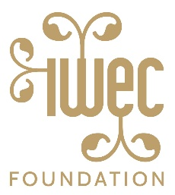

**2026 IWEC Universal Awards Application**

**Conference Title/TBD**

**February 8-10th, 2026 / Manama, Bahrain**

**Deadline for submission: October 30, 2025**

**Contact information**

Name:______________________________________________________________________________

Title:_______________________________________________________________________________

Company name:______________________________________________________________________

Address:____________________________________________________________________________

City, State, ZIP/PIN/Postal Code_______________________________Country____________________

Phone:_____________________________Fax:_____________________________________________

Email address:_______________________________________________________________________

Website:____________________________________________________________________________

Chamber or women’s group affiliation: ____________________________________________________

**Business information**

% of ownership by woman:__________________(must be majority shareholder)

Years in business/date company founded:_________________________(must be a minimum of 3 years)

Annual turnover/revenue:___________________________(must be a minimum of $1.5mill in US dollars)

How many employees do you have?___________(total number of employees throughout your company)

Industry:_________________________________(not including non-profits or performing arts)

***Please attach documents to answer the following questions in 500 words or less per question (additional supporting documents are welcome):***

1. Describe the story of you and your business
2. Why should you be considered for this award?
3. Which countries are you currently doing business with?
4. Which countries would you like to approach with your goods or services? And Why?
5. What is your Business Plan for the next 3-5 years?
6. Have you or are you involved in a Corporate Social Responsibility (CSR) initiative? If so, please describe.

**Additional questions (check answer):**

1. Age range: 20-30___/ 31-40___/41-50____/51-60____ 61-70____
2. Marital Status: Single ___ Married____

If married do you have children? Yes ____ No ____ If so, how many? ____

1. What languages do you speak? ____________________________________
2. Did you participate in sports when you were younger? Yes _____ No______

If yes, was it: an Individual Sport ____ a Team Sport____

What sport was it?_______________________________

1. What do you do for fun? Reading ____Cooking ____Sports ____ Volunteer____

If volunteer, what type of organization? ______________________________

Other activities/interests__________________________________________

1. Does you and your company participate in social media? Yes____ No____

If yes, please check all that apply and note your “handle”:

____ Facebook / Handle:_____________________________

_____LinkedIn / Handle:______________________________

_____Twitter / Handle:________________________________

_____Instagram / Handle:_____________________________

_____WhatsApp / Contact:____________________________

_____You Tube/Link_____________________________________

1. Are you a member of a Board of Directors for a *For-profit company*? Yes____ No____

***Please attach the following documents:***

1. 100-word biography
2. High resolution headshot for usage in video and for print in conference journal and online